1. Build a platform
• operating system: CentOS 7.6 (64-bit)
• Database: SQL Server 2019
• RTC server directory: /www/wwwroot/kefu.rtcim.com/RTCServer
•IP:www.qiyeim.com

2. Install SQL Server
Note: To ensure optimal SQL Server performance, your computer should have at least 4 GB of memory. To download Ubuntu, visit the Ubuntu download website.
curl https://packages.microsoft.com/config/rhel/7/mssql-server-2019.repo | sudo tee /etc/yum.repos.d/mssql-server-2019.repo
sudo yum update
sudo yum install mssql-server

sudo /opt/mssql/bin/mssql-conf setup
Enter 3, select the Express version, and enter your username and password

sudo su
curl https://packages.microsoft.com/config/rhel/7/prod.repo > /etc/yum.repos.d/mssql-tools.repo
exit
sudo yum remove unixODBC-utf16 unixODBC-utf16-devel
sudo ACCEPT_EULA=Y yum install msodbcsql17 mssql-tools
echo 'export PATH="$PATH:/opt/mssql-tools/bin"' >> ~/.bash_profile
echo 'export PATH="$PATH:/opt/mssql-tools/bin"' >> ~/.bashrc
source ~/.bashrc
sudo yum install unixODBC-devel

3. Install PHP

3.1 Install the software store, compile and install "nginx", and "php7.2"

curl https://packages.microsoft.com/config/rhel/7/prod.repo > /etc/yum.repos.d/mssqlrelease.repo

yum install msodbcsql mssql-tools unixODBC-devel

wget http://pecl.php.net/get/sqlsrv-5.9.0.tgz

tar -zxvf sqlsrv-5.9.0.tgz

cd sqlsrv-5.9.0

/www/server/php/72/bin/phpize

./configure --with-php-config=/www/server/php/72/bin/php-config

make && make install

echo "extension = sqlsrv.so" >> /www/server/php/72/etc/php.ini

/etc/init.d/php-fpm-72 reload

cd

wget http://pecl.php.net/get/pdo_sqlsrv-5.8.0.tgz

tar -zxvf pdo_sqlsrv-5.8.0.tgz

cd pdo_sqlsrv-5.8.0

/www/server/php/72/bin/phpize

./configure --with-php-config=/www/server/php/72/bin/php-config

make && make install

echo "extension = pdo_sqlsrv.so" >> /www/server/php/72/etc/php.ini

/etc/init.d/php-fpm-72 reload

/www/server/php/72/bin/php -m|grep -i sqlsrv
For reference: https://blog.csdn.net/qq_38975827/article/details/111470419

3.2 Go to the PHP admin panel and disable the display_errors setting.

4. Configure the site

4.1 The BaoTa platform has added a new site with the domain kefu.rtcim.com (domain number: 98).

4.2 Website directory-Cross-site attack protection feature disabled.

4.3 Pseudo-static

If it is Apache:

RewriteEngine on

RewriteRule (.+)\.html$ $1.php

If it's Nginx:

rewrite /(.+)\.html$ /$1.php;

4.4 SSL Certificate Application (Optional)

5. Configure an online customer service site (optional)

5.1 The BaoTa platform has added a new site with the domain cs.rtcim.com (80).

5.2 Pseudo-static

Apache: No configuration required

Nginx:

# Note: The / is missing after socket.io here

location /socket.io {

proxy_pass http://127.0.0.1:97;

proxy_http_version 1.1;

proxy_set_header Upgrade $http_upgrade;

proxy_set_header Connection "Upgrade";

}

5.3 SSL Certificate Application

5.3 Add a reverse proxy with the target URL: http://127.0.0.1:97.

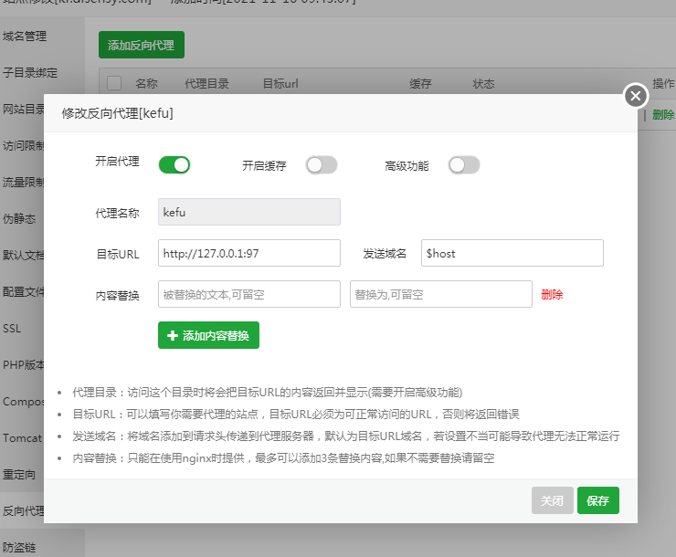

After adding, click the configuration file

Apache:
RewriteEngine On
RewriteCond %{REQUEST_URI} ^/socket.io [NC] RewriteCond %{REQUEST_URI} ^/socket.io [NC]
RewriteCond %{QUERY_STRING} transport=websocket [NC]
RewriteRule /(.*) ws://127.0.0.1:97/$1 [P,L] RewriteRule /(.*) ws://127.0.0.1:97/$1 [P,L]

Nginx: No configuration required

6. Install ffmpeg

sudo yum install epel-release

sudo yum localinstall --nogpgcheck https://download1.rpmfusion.org/free/el/rpmfusion-free-release-7.noarch.rpm

sudo yum install ffmpeg ffmpeg-devel

7. Install Node.js

7.1 Install Redis in the software store.

7.2 Install PM2.

cd /usr/local

# Note: If the server cannot download, upload the node-v10.16.3-linux-x64.tar.xz file from the "Docs\\Installation Guide" directory in the installation package to this directory

wget https://nodejs.org/dist/v10.16.3/node-v10.16.3-linux-x64.tar.xz

xz -d node-v10.16.3-linux-x64.tar.xz

tar xf node-v10.16.3-linux-x64.tar

ln -s /usr/local/node-v10.16.3-linux-x64/bin/node /usr/local/bin/node

ln -s /usr/local/node-v10.16.3-linux-x64/bin/npm /usr/local/bin/npm

ln -s /usr/local/node-v10.16.3-linux-x64/bin/npx /usr/local/bin/npx
npm config set registry http://registry.npm.taobao.org

npm install -g pm2@5.3.1

ln -s /usr/local/node-v10.16.3-linux-x64/bin/pm2 /usr/local/bin/pm2

8. Configuration of RTC Server

8.1 Database Configuration
sudo chmod -R 777 /www/wwwroot/kefu.rtcim.com/RTCServer
sudo chmod -R 777 /var/log
Open http://server ip:98 and configure the database.

8.2 Launch the RTC Server Program
cd /www/wwwroot/kefu.rtcim.com/RTCServer
pm2 start processes.json
cd /www/wwwroot/cs.rtcim.com/KeFu-master
pm2 start bin/www --name kefu

8.3 Configure server address (optional)
System Tools> Background Settings> Message Server IP address: Enter https://kefu.rtcim.com and save.
Online duty-Customer service configuration-Enter https://cs.rtcim.com as the server address and save.

9. Set project startup
pm2 list
pm2 save
pm2 startup
10. Automatically start mssql-server when booting
sudo systemctl enable mssql-server
sudo systemctl start mssql-server
11. Set the server to automatically restart daily or clear sessions weekly
sudo su
vi /etc/crontab
add
00 02 * * * root reboot
00 03 * * 1 root cd /www/wwwroot/kefu.rtcim.com/RTCServer/runtime/sessions && ls |xargs rm -r
00 * * * * root sudo chmod -R 777 /www/wwwroot/kefu.rtcim.com/RTCServer/public/Data
After saving, execute the following
systemctl restart crond.service

